Credit Guarantee
I am familiar with the principles of examination and relevant provisions of the regulations of the disciplines; I will surely conform to the rules of the examination, and be an honest student.
Sign Here ：
Number：
Exam questions（paper）of Northwestern Polytechnical University（NPU）
Scores
2019－2020 school year 2nd semester

Class-taking college 2019级全校国际班 Subject 电路基础 I（英） Class period
Exam Date 2020-7-6 Exam Time 10:30~12:30 Exam Form（closed）（A）paper
Class |  | Student number |  | Name
1. Use mesh analysis to ﬁnd the current in the circuit in Fig.1.
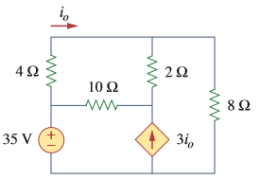
Fig.1

Printed out by academic affairs office Page: 1 of 5

2. Find the maximum power transferred to resistor R in the circuit of Fig.2.
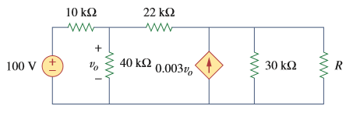
Fig.2

3. Find the equivalent resistance in the circuit of Fig.3.
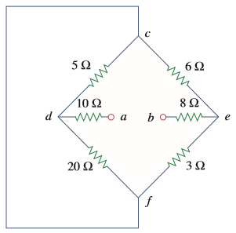
Fig.3

Printed out by academic affairs office Page: 2 of 5

4. Calculate and in the circuit of Fig.4. Find the power dissipated by the resistor.

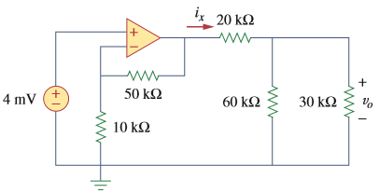
Fig.4

- Find the current and  in the following two-port network in Fig.5.
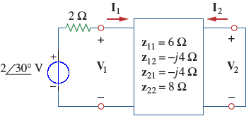
Fig.5

Printed out by academic affairs office Page: 3 of 5

- Determine the equivalent capacitance at terminals a-b of the circuit in Fig.6.
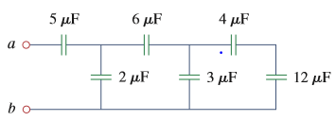
Fig.6

- Find for t<0 and t>0 in the circuit of Fig. 7.
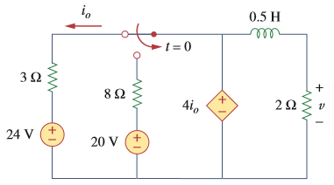
Fig.7

Printed out by academic affairs office Page: 4 of 5

9. Find the value of in the circuit of Fig.9 for maximum power transfer, and calculate the maximum power absorbed by .

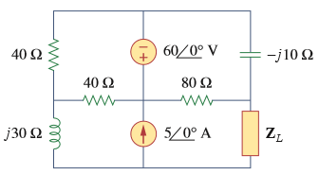
Fig.9

10. A series RLC network has 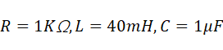. Calculate the resonant frequency and the impedance at resonance.

Printed out by academic affairs office Page: 5 of 5

